C# SDK API

# Introduction

This document will help developers quickly develop RFID-related applications. This development kit is based on the C# language. We provide the source code, you can modify it according to your needs.

## Tag reading process

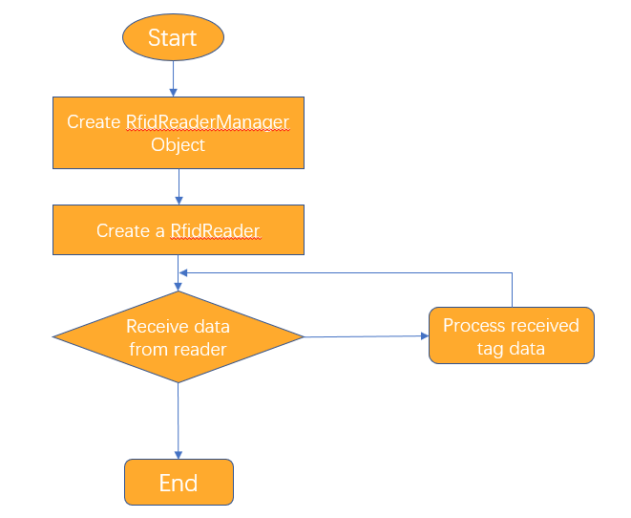

1. Create RfidReaderManager object, it is responsible for adding, deleting reader.
2. RfidReaderManager object also have a thread to travers each reader to receive data. Once receiving data from reader, the manager will notify to application.
3. If you don’t need to receive data any more, please release the resource of reader.
4. You can do some operations like setting parameters through RfidReader object.

# Class Function Description

## 2.1 RfidReader

RfidReader is abstract class. The object it instantiates will be added to RfidReaderManager.

## 2.2 RfidReaderManager

RfidReaderManager class manager reader object and receive data from serial port or net, it is single in program. The following is a description of the method of the class:

### 2.2.1 Instance

|  |  |
| --- | --- |
| public static RfidReaderManager Instance() | |
| Description | Get the instance of RfidReaderManager |
| Parameter | N/A |
| Return | The instance of RfidReaderManager |

### 2.2.2 CreateReaderInSerialPort

|  |  |
| --- | --- |
| Public RfidReader CreateReaderInSerialPort(*String* portName,int baudRate  ,RfidReaderRspNotify notify) | |
| Description | Create a RfidReader object, the object uses serial port to connect to reader |
| Parameter | portName: Serial port name, like COM1, COM11  baudRate: The baud rate of serial port, most of reader’s serial port is 115200  notify: If a response is received, it is reported by the method of the notify. |
| Return | Success: A reader object  Fail: null |

### 2.2.3 CreateReaderInNet

|  |  |
| --- | --- |
| public RfidReader CreateReaderInNet(*String* localIP,*UInt16* localPort,*String* readerIP,*UInt16* readerPort,TransportType type, RfidReaderRspNotify notify) | |
| Description | Create a RfidReader object, the object uses UDP or TCP client transmission. |
| Parameter | LocalIP: IP address where the application is located  localPort: The application  baudRate: The baud rate of serial port, most of reader’s serial port is 115200  notify: If a response is received, it is reported by the method of the notify. |
| Return | Success: A reader object  Fail: null |

### 2.2.4 ReleaseRfidReader

|  |  |
| --- | --- |
| public void ReleaseRfidReader(RfidReader reader) | |
| Description | Remove and release resource from manager |
| Parameter | Reader: release the resource |
| Return | N/A |

## 2.3 MSerialReader

Implementation of the abstract class RfidReader. You can send instructions to the device by this class and response is reported by RfidReaderRspNotify.

### 2.3.1 QueryDeviceInfo

|  |  |
| --- | --- |
| public void QueryDeviceInfo() | |
| Description | Query device information, firmware version number, device type, etc. |
| Parameter | N/A |
| Return | N/A(see RfidReaderRspNotify.OnRecvDeviceInfoRsp) |

### 2.3.2 StartInventory

|  |  |
| --- | --- |
| public void StartInventory() | |
| Description | Notify the device to continuously inventory tags |
| Parameter | N/A |
| Return | N/A (see RfidReaderRspNotify.) |

### 2.3.3 StopInventory

|  |  |
| --- | --- |
| public void StopInventory() | |
| Description | Notify the device to stop inventorying tags |
| Parameter | N/A |
| Return | N/A (see RfidReaderRspNotify. OnRecvStartInventoryRsp) |

### 2.3.4 QueryWorkingParam

|  |  |
| --- | --- |
| public void QeryWorkingParam() | |
| Description | Query the reader’s working parameters |
| Parameter | N/A |
| Return | N/A (see RfidReaderRspNotify. OnrecvQueryWorkParamRsp) |

### 2.3.5 SetDefaultParam()

|  |  |
| --- | --- |
| public void SetDefaultParam() | |
| Description | Restore factory parameters of the device |
| Parameter | N/A |
| Return | N/A (see RfidReaderRspNotify. OnRecvSetFactorySettingRsp) |

### 2.3.6 InventoryOnce

|  |  |
| --- | --- |
| public void InventoryOnce() | |
| Description | 1. The device stops inventorying 2. The device inventory tags one time and stop do it. |
| Parameter | N/A |
| Return | N/A (see RfidReaderRspNotify. OnRecvTagNotify) |

### 2.3.7 SetWorkingParm

|  |  |
| --- | --- |
| public void SetWorkingParam(RfidWorkParam workParam) | |
| Description | Query the reader’s working parameters |
| Parameter | N/A |
| Return | N/A (see RfidReaderRspNotify. OnRecvSetWorkParamRsp) |

### 2.3.8 QueryTransferParam

|  |  |
| --- | --- |
| public void QeryTransferParam() | |
| Description | Query the transmission parameters of the reader |
| Parameter | N/A |
| Return | N/A (see RfidReaderRspNotify. OnrecvQueryWorkParamRsp) |

### 2.3.9 SetAdvanceParam

|  |  |
| --- | --- |
| public void SetAdvanceParam(RfidAdvanceParam advanceParam) | |
| Description | Set the transmission parameters of the reader |
| Parameter | N/A |
| Return | N/A (see RfidReaderRspNotify. OnRecvSetAdvanceParamRsp) |

### 2.3.10 QueryAdvanceParam

|  |  |
| --- | --- |
| public void QeryAdvanceParam() | |
| Description | Set the transmission parameters of the reader |
| Parameter | N/A |
| Return | N/A (see RfidReaderRspNotify.) |

## 2.4 RfidReaderRspNotify

Interface for notification received a response or received tag data, passed as a parameter when creating a RfidReader object by RfidReaderManager.

### 2.4.1 OnRecvTagNotify

|  |  |
| --- | --- |
| void OnRecvTagNotify(RfidReader reader, TlvValueItem[] tlvItems, byte tlvCount) | |
| Description | Notify the application that it has received a tag data |
| Parameter | reader: Reader receiving the response  tlvItems: The tag and other parameter like RSSI. The tag data or the RSSI is one TLV item. For details please reference protocol document.  tlvCount: The TLV counts.s |
| Return | N/A |

### 2.4.2 OnRecvSetFactorySettingRsp

|  |  |
| --- | --- |
| void OnRecvSetFactorySettingRsp(RfidReader reader, byte result); | |
| Description | Notify the result of setting default parameters. |
| Parameter | reader: Reader receiving the response  result: success: 0 fail: others |
| Return | N/A |

### 2.4.3 OnRecvStartInventoryRsp

|  |  |
| --- | --- |
| void OnRecvStartInventoryRsp(RfidReader reader, byte result); | |
| Description | Received a response to start the inventorying |
| Parameter | reader: Reader receiving the response  result: success: 0 fail: others |
| Return | N/A |

### 2.4.4 OnRecvStopInventoryRsp

|  |  |
| --- | --- |
| void OnRecvStopInventoryRsp(RfidReader reader, byte result); | |
| Description | Notify the application that reader has been stop inventory |
| Parameter | reader: Reader receiving the response  result: success: 0 fail: others |
| Return | N/A |

### 2.4.5 OnRecvDeviceInfoRsp

|  |  |
| --- | --- |
| void OnRecvDeviceInfoRsp(RfidReader reader, byte[] firmwareVersion,byte deviceType); | |
| Description | Notify the application the result query device information |
| Parameter | reader: Reader receiving the response  firmwareVersion: the firmware version of reader  deviceType: the type of reader |
| Return | N/A |

### 2.4.6 OnRecvSetWorkParamRsp

|  |  |
| --- | --- |
| void OnRecvSetWorkParamRsp(RfidReader reader, byte result); | |
| Description | Notify the application to set the result of the working parameters |
| Parameter | reader: Reader receiving the response  result: success:0 fail: others |
| Return | N/A |

### 2.4.6 OnRecvQueryWorkParamRsp

|  |  |
| --- | --- |
| void OnRecvQueryWorkParamRsp(RfidReader reader, byte result, RfidWorkParam workParam); | |
| Description | Notify the application that it has received a tag data |
| Parameter | reader: Reader receiving the response  workParam: the reader’s working parameters. |
| Return | N/A |

### 2.4.7 OnRecvSetTransmissionParamRsp

|  |  |
| --- | --- |
| void OnRecvSetTransmissionParamRsp(RfidReader reader, byte result); | |
| Description | Report the result of setting the transmission parameters |
| Parameter | reader: Reader receiving the response  result: success:0 fail: others |
| Return | N/A |

### 2.4.8 OnRecvQueryTransmissionParamRsp

|  |  |
| --- | --- |
| void OnRecvQueryTransmissionParamRsp(RfidReader reader, byte result,  RfidTransmissionParam transmissiomParam); | |
| Description | Notify the application that it has received a tag data |
| Parameter | reader: Reader receiving the response  transmissionParam: the reader’s transmission parameters |
| Return | N/A |

### 2.4.9 OnRecvSetAdvanceParamRsp

|  |  |
| --- | --- |
| void OnRecvSetAdvanceParamRsp(RfidReader reader, byte result); | |
| Description | Notify the application that it has received a tag data |
| Parameter | reader: Reader receiving the response  result: the result of setting advance parameters.  Success:0 Fail:others |
| Return | N/A |

### 2.4.10 OnRecvQueryTransmissionParamRsp

|  |  |
| --- | --- |
| void OnRecvQueryTransmissionParamRsp(RfidReader reader, byte result,  RfidTransmissionParam transmissiomParam); | |
| Description | Notify the application that it has received a tag data |
| Parameter | reader: Reader receiving the response  transmissionParam: the reader’s transmission parameters |
| Return | N/A |